Amazon Store (https://www.amazon.co.uk) was considered as a case study for exploring both relational and non-relational database design. The large volume and complexity of its data make this e-commerce platform suitable for analysing different database approaches.
I. Relational Design
1. Database Design Process
To begin the database design process, it is important to clarify the following key aspects:
1.1. what data needs to be stored;
1.2. how data access should be controlled;
1.3. relevant business rules;
1.4. and the main use cases of the data.
1.1. Amazon needs to store:
- Customer-related information: user account information (name, email, address), payment details, order history, search behaviour.
- Product-related information: product details, pricing information, stock levels, seller information.
1.2. Data access requirements.
Access to the data should be strictly controlled. Users should only be able to access their own personal and order data through secure authentication mechanism. Sensitive information, such as payment data, should be encrypted. Internal access should follow role-based access control, where only authorised employees can access specific data required for their role.
1.3. Business rules.
Several business rules influence how Amazon manages its data.
Legal regularisations (GDPR) require personal data to be stored securely and deleted when it is no longer necessary. In additions, transaction data must be retained for accounting, auditing and fraud prevention purposes.
Pricing and availability rules may vary by country, meaning that some data must be stored and accessed differently depending on the user’s location.
1.4. Use cases.
The stored data is used for multiple purposes. User behaviour and purchase history are analysed to provide personalised product recommendations and targeted offers. Transaction data supports order fulfilment, delivery tracking and customer support. Aggregated data is also used for business analytics, demand forecasting inventory management, helping Amazon optimise its operations and improve overall user experience.

2. Main database entities
Amazon database might include the following main tables:
- Customers: customer_id (PK), first_name, last_name, email, phone, country, city, address, customer_registration_date;
- Products: product_id (PK), category_id (FK), seller_id (FK), product_name, brand, description, price, stock_quantity, product_added_date;
- Orders: order_id (PK), customer_id (FK), order_date, order_status, returned, total_amount;
- Order_Items: order_item_id (PK), order_id (FK), product_id (FK), quantity, item_price;
- Categories: category_id (PK), category_name;
- Sellers: seller_id (PK), seller_name, contact_details
- Deliveries: delivery_id (PK), order_id (FK), shipping_address, delivery_status, tracking_number;
- Payments: payment_id (PK), order_id (FK), payment_method, payment_status, payment_date;
- Reviews: review_id (PK), customer_id (FK), product_id (FK), rating, comment, review_date.
Three top entities are analysed for relational database design: Customers, Products and Orders. There are two binary relationships between Customers – Orders and Orders – Products tables, which are visualised in the ER – diagram.
ER – diagram
1
M
M
1
Customers
Products
Orders

One Customer can have many Orders (one – to – many relationship)
One Order belongs to one Customer (many – to – one relationship)
One Order contains one Product (many – to – one relationship)
One Product can be in many Orders (one – to – many relationship)
The Orders table contains its own primary key (order_id) and two foreign keys: customer_id referencing Customers and product_id referencing Products.
It is important to note that one order may contain multiple products and in a full database design there is a separate Order_Items table, which contains product_id, quantity and item_price, and supports many-to-many relationship between Orders and Products. However, in this simple model of three entities, these attributes are included in the Orders table, and each order contains only one product. Addresses are usually stored in a separate table as well because a user can have several addresses (home, work, etc.); an address can change; one order can have a different delivery address. In this simplified model, the Customers table contains an address, and the Orders table contains a shipping_address.
Database Schema
Represented database design satisfies the First and Second Normal Forms (1NF and 2NF), as all attributes are atomic and fully dependent on their primary keys. However, the design only partially satisfies the Third Normal Form (3NF), as the Orders table stores product-related information (such as product_id, quantity, and item_price) directly. As was mentioned before, in a full database design, this issue could be resolved by introducing a separate Order_Items table to better normalise the database.
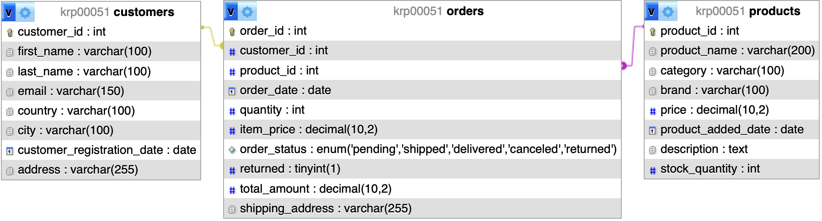
 | 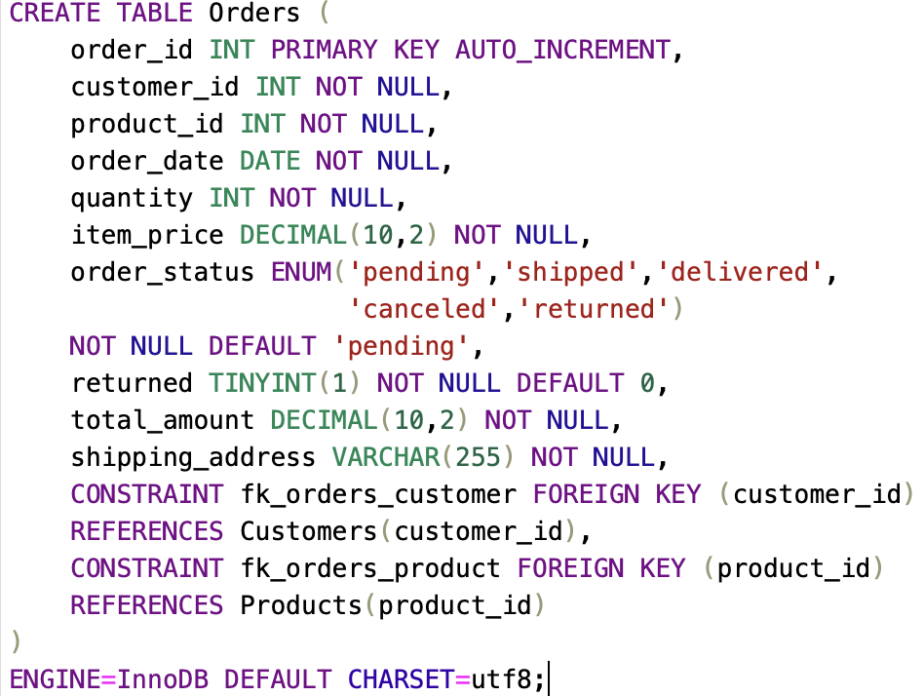 | 

Data integrity in this database is maintained using various constraints, including primary keys, foreign keys, NOT NULL, UNIQUE, and ENUM constraints.
- Entity Integrity is applied by using a primary key to prevent duplicate entries.
- Referential Integrity is maintained by foreign key constraints in the Orders table, which links Customers and Products. This ensures that an order cannot exist without a valid customer or product.
- Domain integrity is also ensured by using appropriate data types.
- NOT NULL constraints are applied to essential attributes to prevent missing or incomplete data in the database.
- UNIQUE Constraint is applied to the email field in the Customers table to ensure that each customer has a unique email address to prevent duplicate user accounts.
- ENUM Constraint is used for the order_status attribute with predefined values (pending, shipped, delivered, cancelled, returned), ensuring consistency and preventing invalid entries.
- DEFAULT values are used to automatically assign initial values to improve data consistency and reduce the need for manual input.

3. SQL Queries
3.1. How many clients register each month in each country
For e-commerce companies (such as Amazon), this is one of the most important queries to analyse business performance and market growth. If the number of new customers is growing, the business is attracting more users. If it is decreasing, this may suggest problems: poor advertising, competitors or website issues.
By including country information, it is possible to identify which markets are growing faster. For example, if a marketing campaign is launched in Germany and registrations increase significantly in March, this indicates that the campaign is effective.
Additionally, more customers lead to more orders, more warehouse load and more deliveries. Therefore, this information helps businesses make decisions such as opening new warehouses, increasing logistics, etc.
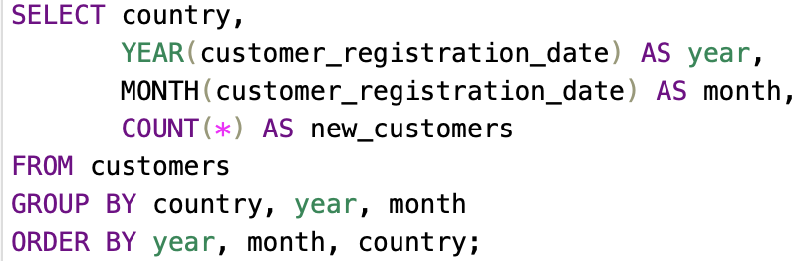

3.2. The products with the most sales and the fewest returns
Products with the highest sales and the lowest number of returns are the best products for the business.
These products indicate high customer satisfaction, as they meet customer expectations and minimise return and logistics costs.
Such products should be actively promoted, kept in large quantities in stock and included in recommendations to increase sales and profitability.
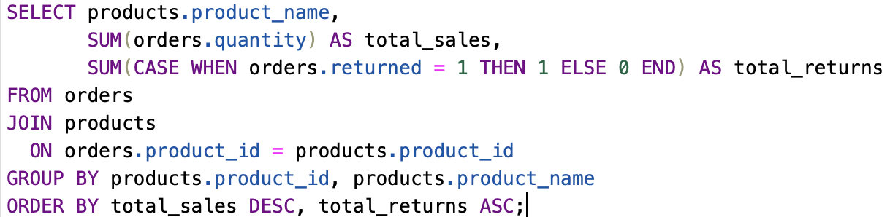

3.3. Customers who spend the most money over the last 3 months
This query helps to analyse customer behaviour over time, identify high-value customers. Customers who spend more are more likely to trust the platform, return more frequently, and make repeat purchases. Therefore, such customers can be targeted with discounts, bonuses, and loyalty programmes such as Prime membership.
It is also very important for Amazon recommendations, email marketing, trend analysis.
Additionally, this query supports behaviour prediction. For example, if a customer previously spent a lot and then stopped, this may indicate a risk of churn. In this case, the company can take actions such as offering discounts or sending reminders.
Besides, this query helps identify which customers contribute most to total sales, which customer groups are more important (often 20% of clients = 80% of profits).
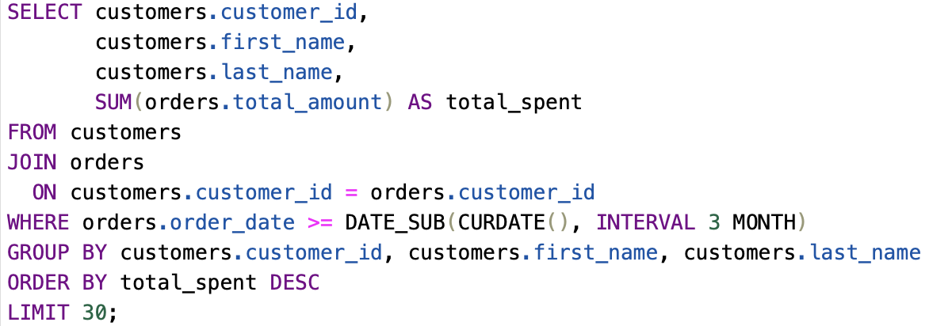

II. NoSQL Design

2 NoSQL Design
Consider that your website serves a large global market, it probably needs something more flexible than a relational database. Explain the limitations of a relational database and how the use of a distributed document store such as MongoDB would help you overcome those limitations. Make sure you refer to the website you chose to illustrate the points you are making.
Now provide a detailed document model for a MongoDB store for the data you identified in part 1. Give example documents and explain the possible solutions you would have when replacing the relational elements such as foreign keys and normalisation. Describe the decisions you would need to make when distributing the database across a cluster and give examples based on the website you have chosen.
Finally, as before, suggest three queries that might need to be made of the database and give the MongoDB syntax required to carry them out.

